**KASIYE TAYE ESHETE**

**1.INTERFACE**

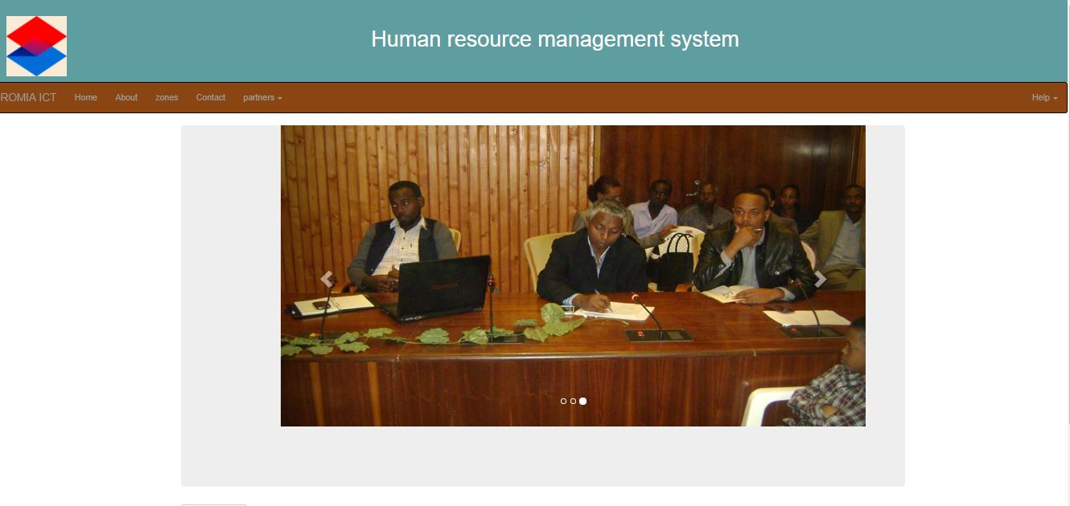

LOGIN PAGE

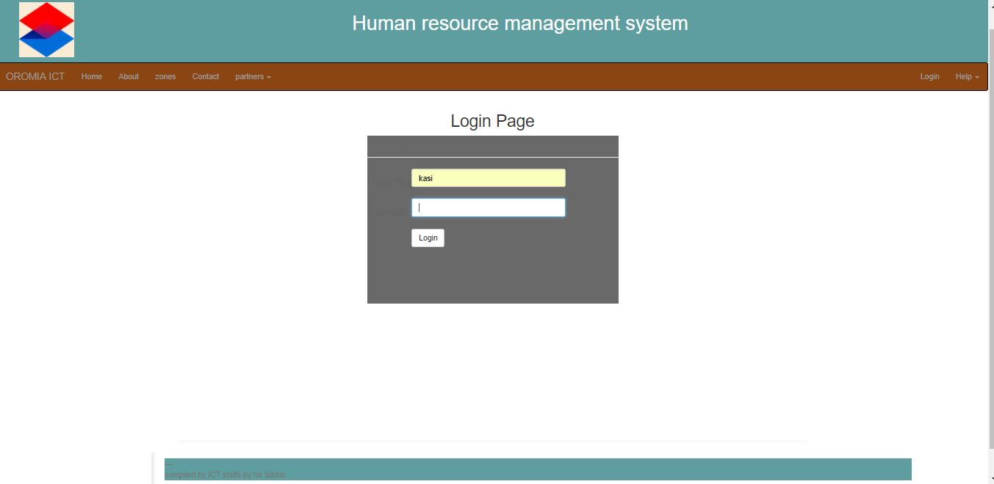

ACCOUNT REGISTRETION FORM

VALIDATION

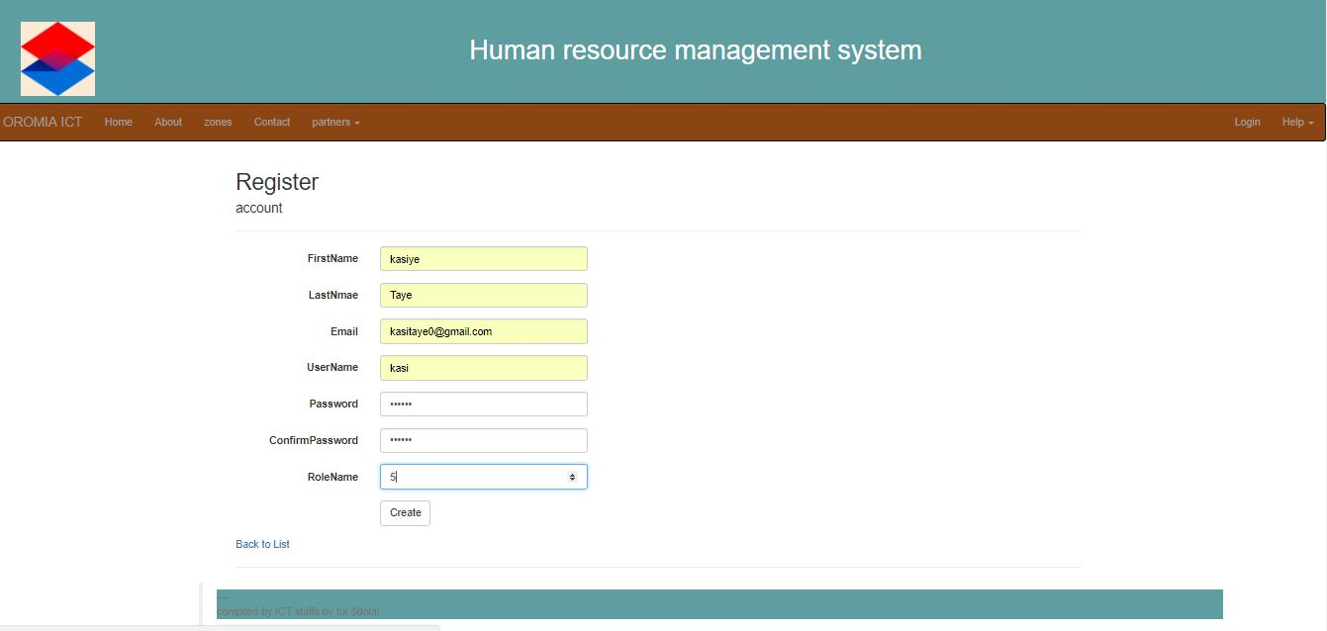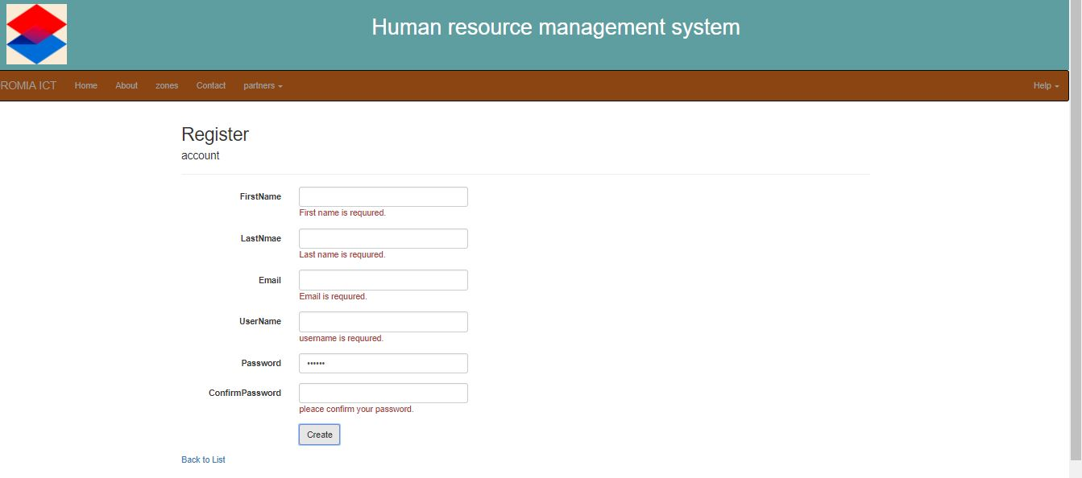

EMPLOYEE REGISTRETION FORM

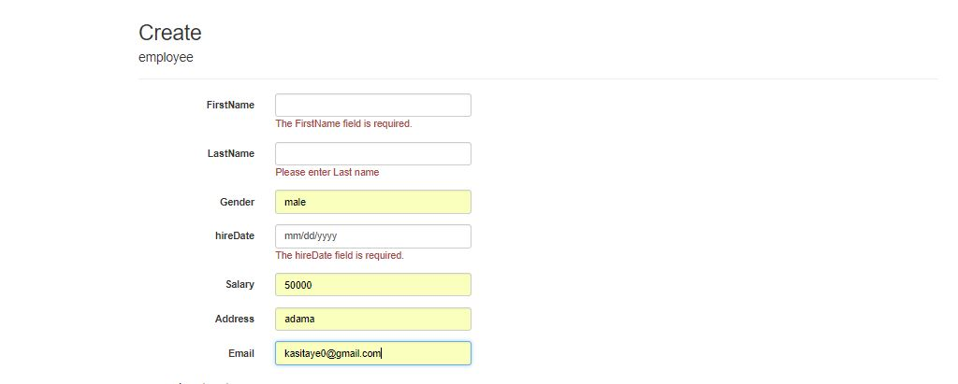

LIST OF EMPLOYEEE

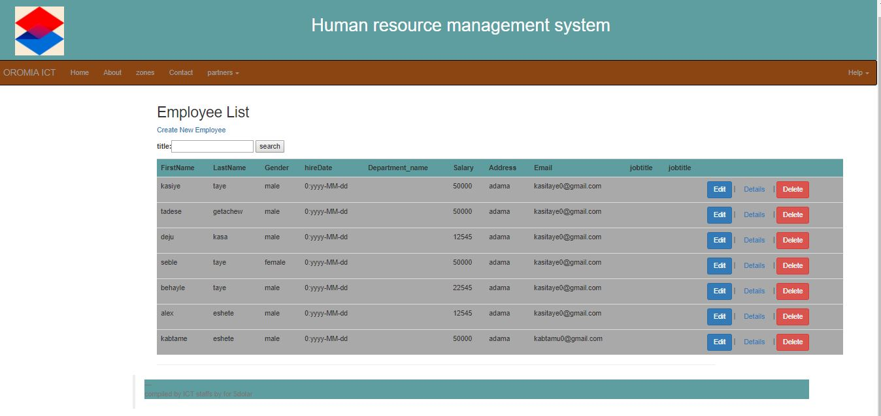

**SMS MESSAGE**

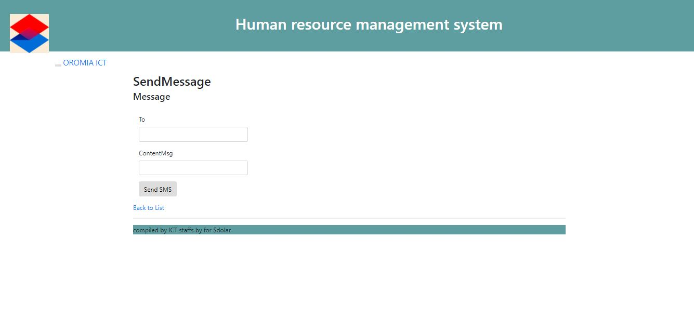

CREATE ROLE

